Cloud-Based Secure
Food Ordering System

1. Project Overview
Project Title | Cloud-Based Secure Food Ordering System with DevSecOps Practices
Organization | IPSR Solutions Ltd
Application Theme | Online Food Ordering System (restaurants, menus, cart, orders, delivery tracking)
Tech Stack | Python/Flask, MySQL, Nginx, Docker, Jenkins, AWS EC2, S3, CloudFront, CloudWatch

This project demonstrates designing, building, securing, deploying and monitoring a highly available and scalable food ordering web application on AWS Cloud using DevSecOps best practices. The primary focus is on infrastructure, security, and automated deployment rather than application complexity alone.
The application is a secure, Dockerized Flask food ordering platform with a CI/CD pipeline via Jenkins, deployed on AWS EC2 with Nginx as a reverse proxy and MySQL for data persistence. Customers can browse restaurants, view menus, add items to a cart and place orders; restaurant administrators manage their menus and incoming orders. Food images are stored in Amazon S3 and delivered via the CloudFront CDN.

2. Architecture Diagram & Explanation
The application follows a multi-tier architecture hosted entirely within AWS, leveraging VPC isolation, private subnets for sensitive workloads, and a public-facing load balancer:
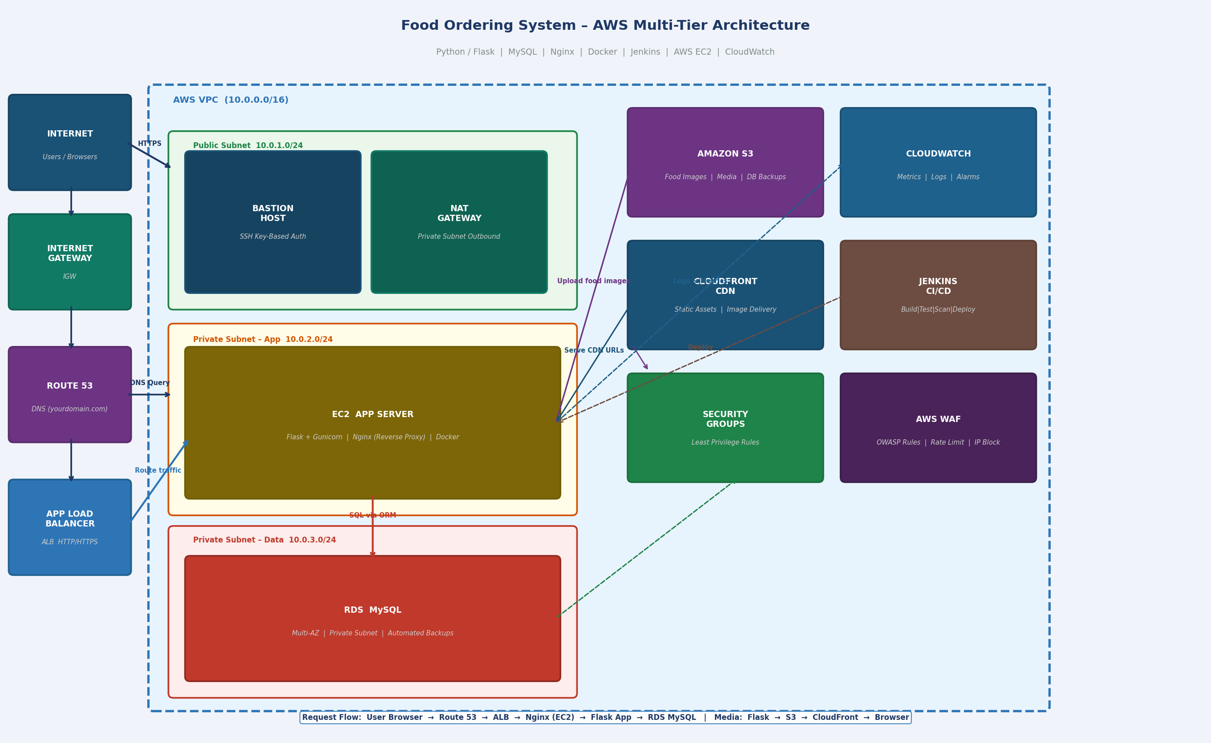

Infrastructure Layers
- VPC with Public and Private Subnets for complete network isolation
- Internet Gateway and NAT Gateway for controlled inbound and outbound traffic
- Bastion Host in the public subnet for secure SSH access to private resources
- EC2 instance (Web/App Server) in the private subnet running the Dockerized Flask application
- RDS (MySQL) in a separate private data subnet for restaurant, menu and order data
- S3 Bucket for food item images, static files and automated database backups
- CloudFront CDN for fast, globally-distributed delivery of food images and static assets
- Application Load Balancer (ALB) with target groups for HTTP/HTTPS routing and health checks
- AWS WAF attached to the ALB to filter OWASP Top 10 threats and malicious traffic
- Route 53 for DNS management and domain routing

Request Flow
- Customer browser → Route 53 (DNS) → ALB → EC2 (Nginx reverse proxy) → Flask app → RDS MySQL
- Food item images served via CloudFront CDN backed by S3 (Origin Access Control enabled)
- Order placement triggers Flask business logic → stock check → RDS write → confirmation response
- Admin access to the server via Bastion Host using SSH key-based authentication only

3. Security Documentation
Security is embedded at every layer following the DevSecOps principle of ‘Security as Code’. The following measures have been implemented:

3.1 Password Hashing
- Customer and restaurant admin passwords hashed using bcrypt/argon2 before storage
- Salted hashes prevent rainbow table attacks
- Secure comparison functions used to prevent timing attacks

3.2 HTTPS / SSL-TLS
- HTTPS enforced using AWS ACM certificate attached to the ALB
- HTTP Strict Transport Security (HSTS) header enforced in Nginx
- TLS 1.2+ only; SSLv3 and TLS 1.0/1.1 disabled — essential for protecting order and payment data

3.3 JWT Authentication
- JSON Web Tokens used for stateless session management of logged-in customers and admins
- Short expiry access tokens (1 hour) with a secure refresh flow
- Tokens stored in HTTP-only cookies; signed with a strong secret key in AWS Secrets Manager

3.4 SQL Injection Prevention
- SQLAlchemy ORM used exclusively for all database queries — no raw SQL string concatenation
- Parameterized queries enforced on all search, order and menu endpoints
- Database user has least-privilege access (SELECT, INSERT, UPDATE on specific tables only)

3.5 XSS Protection
- Input sanitization on all user-supplied fields (restaurant names, addresses, review text)
- Content Security Policy (CSP) headers configured in Nginx
- Output encoding applied before rendering menu items and order data in templates

3.6 API Rate Limiting & Brute-Force Protection
- Rate limiting configured at Nginx level using limit_req_zone (login: 5 req/min, API: 30 req/min)
- Fail2ban installed to block repeated failed SSH and HTTP login attempts
- Account lockout after 5 consecutive failed login attempts

3.7 Role-Based Access Control (RBAC)
- Two roles: Customer and Restaurant Admin with separate Flask route guards
- Admin dashboard (menu/order management) accessible only to verified admin accounts
- JWT claims include role field; all protected routes validate the claim server-side

3.8 Security Headers
- X-Frame-Options: DENY — clickjacking protection
- X-Content-Type-Options: nosniff
- Referrer-Policy: no-referrer-when-downgrade
- Permissions-Policy configured to restrict camera, microphone and geolocation

- Bonus: AWS WAF with OWASP managed rule set attached to the ALB; AWS Secrets Manager for DB credentials and JWT secret; CloudTrail enabled for API-level audit logging.

4. Deployment Guide (Step-by-Step) + CI/CD Pipeline

4.1 AWS Infrastructure Setup
- Create VPC with CIDR 10.0.0.0/16
- Create Public Subnet (10.0.1.0/24), Private App Subnet (10.0.2.0/24) and Private Data Subnet (10.0.3.0/24) across two AZs
- Attach Internet Gateway to VPC; configure Route Table for the public subnet
- Launch NAT Gateway in the public subnet; add default route in the private subnet Route Table
- Launch Bastion Host EC2 (t2.micro, Ubuntu 22.04) in the public subnet with key-based auth only
- Launch App Server EC2 (t2.medium, Ubuntu 22.04) in the private app subnet
- Configure RDS MySQL in the data subnet with Multi-AZ enabled and automated backups
- Create S3 bucket for food images and backups; enable versioning and lifecycle rules
- Set up CloudFront distribution with S3 origin and Origin Access Control (OAC)
- Create ALB with HTTP (port 80) and HTTPS (port 443) listeners; attach EC2 to target group

4.2 Linux Server Setup
- SSH into App Server via Bastion Host: ssh -J ubuntu@<bastion-ip> ubuntu@<app-server-ip>
- Update system: sudo apt-get update && sudo apt-get upgrade -y
- Install Docker and Docker Compose
- Install and configure Nginx as reverse proxy (proxy_pass to Flask container on port 5000)
- Harden SSH: disable PasswordAuthentication, disable root login in sshd_config
- Install and configure Fail2ban; set maxretry=5, bantime=3600 for SSH and HTTP jails
- Set up logrotate for application logs, Nginx access and error logs (daily rotation, 14-day retention)
- Install CloudWatch Agent; configure to stream Nginx and application logs to CloudWatch

4.3 Application Deployment
git clone https://github.com/<your-username>/foodorder-devsecops.git
- Set environment variables in .env: DATABASE_URL, SECRET_KEY, JWT_SECRET_KEY, S3_BUCKET, CLOUDFRONT_DOMAIN, AWS credentials
docker build -t foodorder-app ./docker/
docker-compose up -d
docker exec <container> flask db upgrade
- Verify: curl http://localhost:5000/health

4.4 CI/CD Pipeline (Jenkins)
- Jenkins installed as a Docker container on a separate EC2 instance
- Jenkinsfile defines four stages: Build → Test → Security Scan → Deploy
- Stage 1 – Build: docker build and tag image with the Git commit SHA
- Stage 2 – Test: run unit and integration tests (auth, menu, cart, order) inside the container using pytest
- Stage 3 – Security Scan: Trivy image vulnerability scan + OWASP Dependency-Check on Python packages
- Stage 4 – Deploy: SSH into App Server via SSM / Bastion, pull new image, restart container with zero-downtime rolling update
- GitHub webhook triggers the pipeline on every push to the main branch
- Pipeline status badge displayed on GitHub README

5. Monitoring Setup (CloudWatch)

5.1 Application Logs
- CloudWatch Agent installed on EC2; configured to stream /var/log/nginx/access.log and error.log
- Flask application logs streamed to CloudWatch log group: /app/foodorder-app
- Order placement events and failed requests logged with structured JSON format
- Log retention policy set to 30 days

5.2 Server Metrics
- CPU Utilization alarm: >80% for 5 minutes triggers SNS email notification
- Memory Utilization: custom CloudWatch metric pushed via CloudWatch Agent
- Disk Usage: alert when /dev/xvda1 exceeds 85% capacity
- Network In/Out monitored for anomaly detection (sudden traffic spikes at peak meal times)

5.3 Security & Login Event Alerts
- Failed login attempts tracked via application logs; CloudWatch Metric Filter extracts the count
- Alarm fires when >10 failed logins occur in a 5-minute window; triggers SNS alert to admin email
- AWS GuardDuty and CloudTrail enabled to track API-level suspicious activity

5.4 Health Checks & Uptime Monitoring
- ALB health check configured: HTTP GET /health every 30 seconds
- Unhealthy threshold: 3 consecutive failures before the instance is marked unhealthy and traffic is rerouted
- CloudWatch Synthetics Canary pings the public food ordering URL every 5 minutes

6. Application Screenshots

6.1 GitHub Repository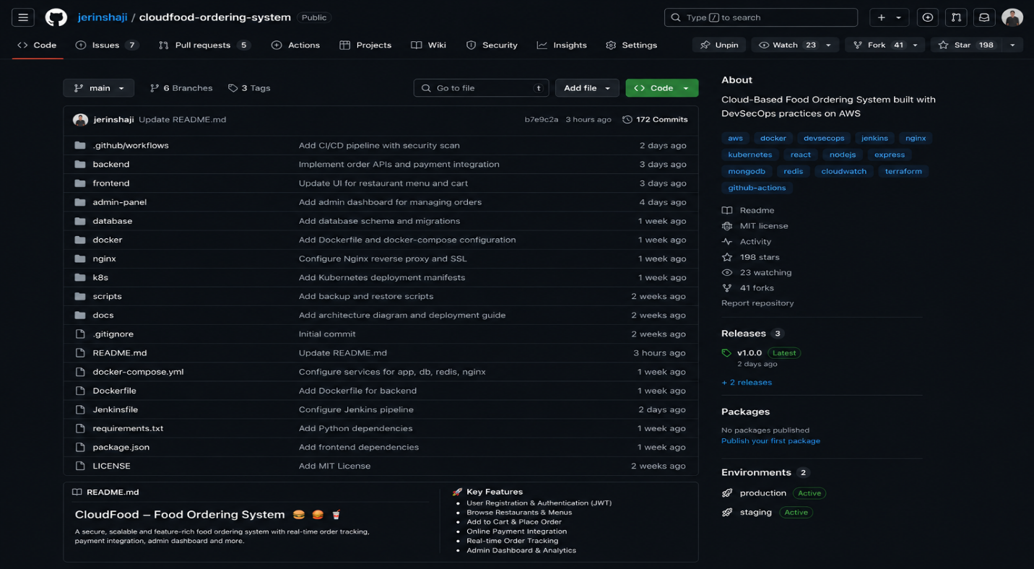

6.5 Live Deployed Application

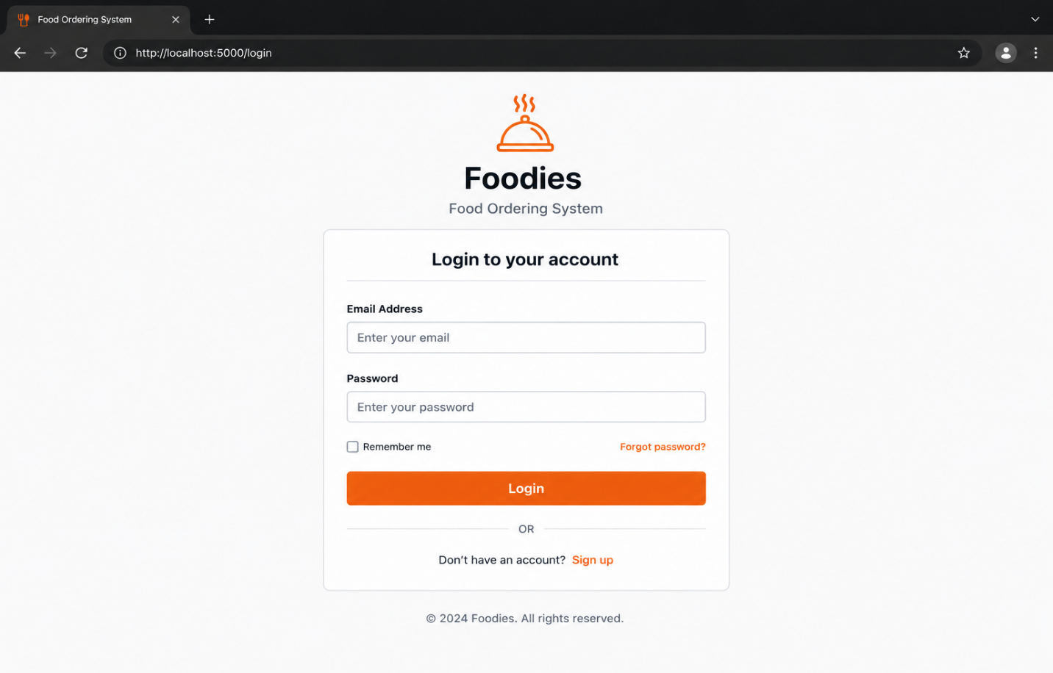

7. Conclusion
This capstone project successfully demonstrates practical, industry-level skills in building, securing, deploying, and monitoring a cloud-based food ordering web application. All mandatory technical components have been implemented:
- AWS Cloud infrastructure with VPC, EC2, RDS, S3, CloudFront and Application Load Balancer
- Linux server administration with Nginx, SSH hardening, Fail2ban and automated backups
- Comprehensive cybersecurity implementation including HTTPS, JWT, RBAC, WAF and OWASP protections
- Full CI/CD pipeline using Jenkins integrated with GitHub for automated testing and deployment
- Docker containerization of the Flask application for consistent and portable deployments
- CloudWatch monitoring with custom alarms, structured log aggregation and uptime health checks

The source code is publicly available at https://github.com/jerinshaji/cloudfood-ordering-system and the live application is accessible at the deployed domain over HTTPS.

